/\*\*\*\*\*\*\*\*\*\*\*\*\*\*\*\*\*\*\*\*\*\*\*\*\*\*\*\*\*\*\*\*\*\*\*\*\*\*\*\*\*\*\*

\* Programming excercise 73003 \*

\* Maxwell Stephens \*

\* 12:30 TTh \*

\* 73003, 2/21/17 \*

\*\*\*\*\*\*\*\*\*\*\*\*\*\*\*\*\*\*\*\*\*\*\*\*\*\*\*\*\*\*\*\*\*\*\*\*\*\*\*\*\*\*\*/

/\*

A program that calculates and prints the total grade for n assignments

as a percentage.

\*/

#include <iostream>

using namespace std;

int main()

{

//declare vars

int n, i;

double pointsPossible, pointsRecieved, totalBank = 0, resultBank = 0, overallPercentage;

//ask for assignment number

cout << "How many assignments are there total?\n";

//get n

cin >> n;

//for loop to loop as many times as n value is

for (i = 1; i < n + 1; i++)

{

//taking in points possible

cout << "What are the total points possible for assignment " << i << "?\n";

//get points possible

cin >> pointsPossible;

//taking in points recieved

cout << "How many points were recieved for assignment " << i << "?\n";

//get points recieved

cin >> pointsRecieved;

//add to result bank pointsRecieved

resultBank += pointsRecieved;

//add to total bank pointsPossible

totalBank += pointsPossible;

}

//calculate overallPercentage

overallPercentage = (resultBank / totalBank) \* 100;

//output points recieved out of total points possible and give overallPercentage

cout << "Your total amount of points is " << resultBank << " out of " << totalBank << " and your final percentage is " << overallPercentage << "%\n";

system("pause");

return 0;

}

/\*

SAMPLE OUTPUT:

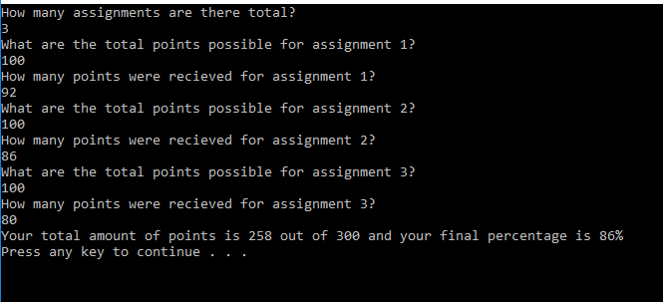

Self-Evaluation:

4: Works perfectly, code properly documented

I believe I earned 4 points.

\*/